**international** **applications;**

**1-London Live Bus Times Countdown -Timetable Checker**

**By Mobicia**

This app is only available on the App Store for iOS devices

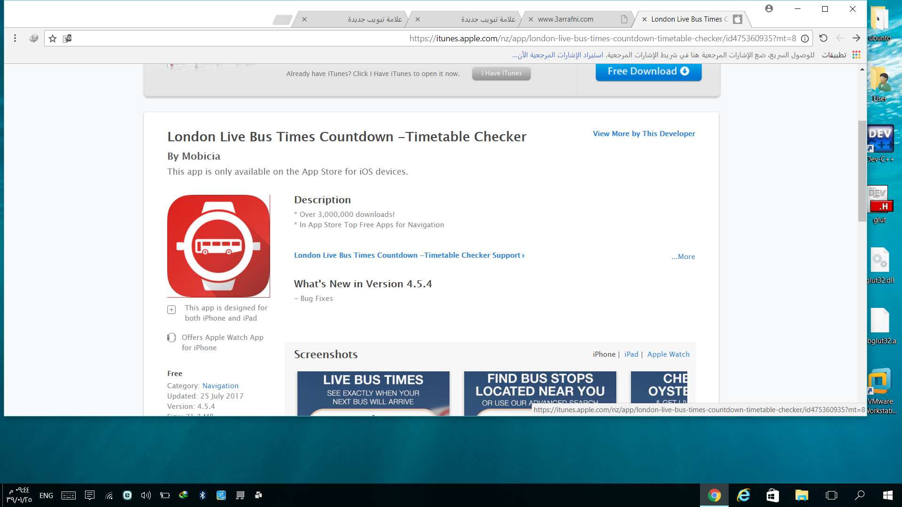

**Description:**

 Over 3,000,000 downloads!  
* In App Store Top Free Apps for Navigation  
  
London Bus Timing Countdown tells you when your next bus will arrive at any bus stop in London using the data directly from TFL.   
  
**NEW**  
- Timetables: See bus timetable information at any bus stop.  
- Improved Journey Planner UI  
- Line Status: Bus Routes, Tube & Rail  
- Live Cams: View live video from TfL Traffic Cams  
- Santander Cycles: Find your nearest docking stations and view live cycle and free space counts  
- Improved Accessibility: Give us your feedback so we can improve  
* My Buses Feature lets all the bus times that matter to you on one screen.  
* Redesigned Bus Stops screen - Nearest / Favourites / Recents on one page  
* NEW Travel Status Updates  
* Phone Snatch Safety Alerts - Please note messages from the Metropolitan Police Service about phone snatch are available in selected locations only on a trial basis.  
* Journey Planner - Find the best route to your destination and avoid delays  
* Choose between the new bus time view and the old bus time view via an easier to find option.  
* Fixes to ordering of favorites  
***Features***:  
* Instantly tell when your bus is due  
* Finds bus stops near you using your iPhone's GPS  
* Oyster Balance Viewer  
* New Journey Planner  
* Travel Status Bus, Tube & National Rail Disruption Updates - See alerts on your most used lines  
* Hold down anywhere on the map to see the nearest bus stops to that area  
* Live Bus times for Transport for London (TFL) bus stops showing when the next buses will arrive.  
* Bus stops on the map show the direction the buses are heading  
* View nearest stops on a map  
* Automatic Refresh of Bus Times Countdown so your list is always up to date  
* Search for bus stops by postcode or bus stop name  
* Displays Bus Stop Notices eg: Closures/Diversions/Disruptions Notices  
* Save your favourite bus stops in your Favourites for quick access.  
* Road Traffic News - Bus Route Disruptions  
Please note that continued use of GPS running in the background can dramatically decrease battery life.  
  
Please be aware that this app requires an internet connection and Location services turned on for full functionality.  
  
* This app uses the Bus countdown feed from TFL, and they occasionally do maintenance in which case the application will show no results. We cannot be 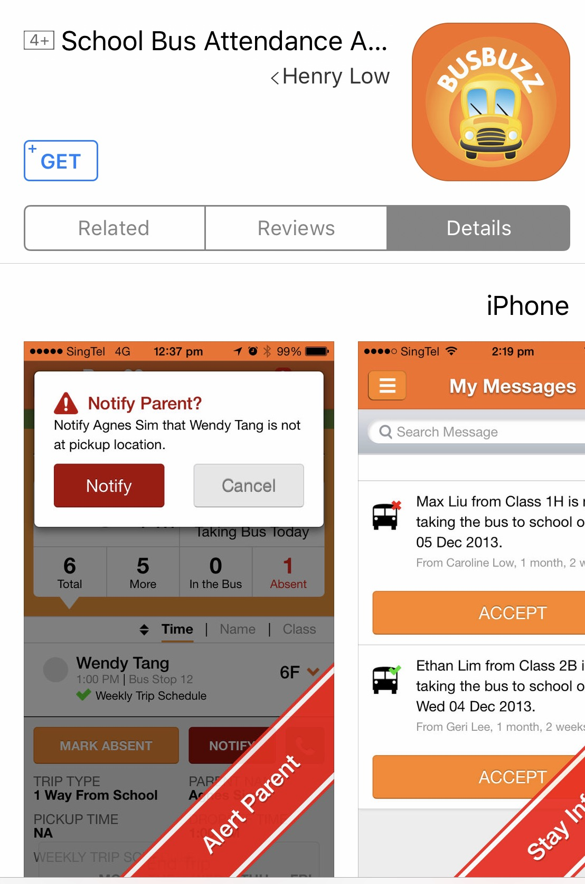held responsible for any unavailability or inaccuracies displayed by this app.

**2-school bus buzz**

BusBuzz is a school bus control application that allows parents to know immediately when your child has boarded a school bus, ensure your child's safety and gives you peace of mind. Knowing your child's attendance status, you can take appropriate action immediately and law right away if you are aware before your operator bus that your child is not in the capture location. Please note: The school bus operator must be registered with BusBuzz using a separate free BusBuzz link application on the attendance attendant. Parents must be calling through your bus operator in order to start using BusBuzz. If you know that your bus operator has not started using the free BusBuzz link application, please help us by recommending them BusBuzz, so that you can enjoy the benefits of knowing your child's attendance status. Parents • Stay informed on a daily schedule of the trip with boarding / get off time and attendance status • Receive alerts immediately from child absence status • Provide alarm on bus operator from change in child bus attendance at any time, anywhere • Reduce and avoid bad communication by phone calls _____

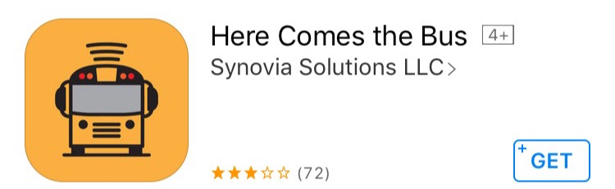

**3-here comes the bus**

Description **NOTICE: In order to use the app, your school district must have a contract with Synovia Solutions and make Here Comes the Buse and/or Student Ridership available to parents. Please contact your school district or visit[www.herecomesthebus.com](http://www.herecomesthebus.com/) for more information.** Here Comes the Bus is an easy-to-use app that gives you the real-time location of your child's bus, and alerts you when the bus is near. With Here Comes the Bus, your children will get to the bus stop not a minute too early or a minute too late. And with Student Ridership, you'll not only know your child got on the right bus at the right time, but that they got off the bus at the right stop. All of this equals safety for your children, and peace of mind for you. KEY FEATURES: Find your bus quickly and easily See the exact location of your child's school bus using your own customizable map. Receive alerts via push notification Be notified when the bus is within 2 miles of your stop, has a schedule change, and more Receive notifications when your child gets on/off the bus, including the bus number, location and time

Access arrival & departure info Confirm your child's bus has arrived at the bus stop and at school, both before and after school. Track all of your children Have children that ride different buses? See each child's bus information within one account. App and notifications in three languages The app and notifications are available in English, Spanish and French Know your privacy is protected Parents must obtain a private ID number, which grants access to their child's bus only



**4-smart school bus**

**Description**

 As a parent, safety is a principal concern. Imagine you can keep track of your child’s safety while on the school bus, or arriving to his destination (the school), or entering the school with the rest of the kids, and coming back home on time. Well, guess what? You don’t have to just imagine it because with Smart School Bus™ Solution you actually can keep get it

***? what is Smart School Bus***

The Smart School Bus™ Solution is an automated system monitored by an Operational Control Centre (OCC) that allows the movement and location of school children to be monitored during transportation to and from their school, anytime, anywhere.

***Smart School bus™ Solution offers so many features:***

Automated system monitored by an Operational Control Centre (OCC)1-

. Real Time Streaming of the Video and Voice about the activities in the School bus-2

Auto Alerts; Parents can monitor the movement of their child-3.

Bus arrived at collection point (e.g. house or apartment)-

Child entered the bus and is on the way to school-

-Child disembarked at the school

-Child entered the bus and is on the way home

-Child has arrived home

4-Bus Logs

Audible alert on the bus-

Communication directly to Control Centre-

. 5- Fleet Management solution

Bus Speed.-

Inside Bus Activity.-

Route Management-

Driver recognition-

-Service Schedule

-Anti-Theft

-Activity Reports

Smart School Bus™ ***Solution gives you the peace of mind during your child trip from and to school, it also:***

.  1-Ensures safety and security for the students during the trip from house to school and vice versa.

2-Parents have the option access the solution and monitor the movement of their children.

. SMS/Email/Mobile App alerts will be sent to the parents whenever is needed

-3-Series of electronic alerts customized for each child individually, depending on the location point of your child.

-An SMS will be sent informing the parent, that the bus is close to pick up or to drop the child. By this way each child is not left alone on the street waiting the bus or the maid.

**BasuKoko: 5-**

Is a foreign application can check the current status of the bus is used for kindergartens.

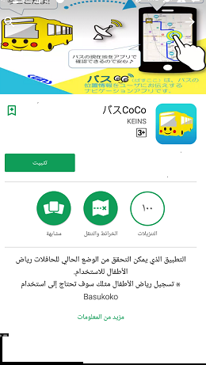

**School Bus: AVL VIEW GPS tracking System 6-** 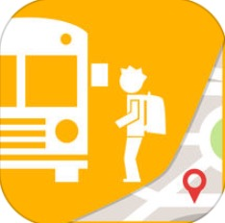

**Description:**

The wait is over! You can now download AVL View's much awaited module for School Bus app for parents. With [app.avlview.com](http://app.avlview.com/), schools can now create schedules, assign pickup/drop off points for buses and let parents know when their kids' school bus is approaching stoppage/pickup/drop off points. School module features in AVL View include: Create pre-scheduled trips for school busses. Assign a specific route (route fence) through which the busses have to travel Include student pick-up/drop points as waypoints. School management will receive notification alerts (by SMS/email) on schedule violations (mismatching in times, route deviations & missed stoppages) Add students to school bus module with their grade info (class, division etc) eg: VII C Assign students to scheduled trips and assign their stops too. Multiple trips can be assigned for students (students will have at least 2 trips assigned pickup/drop off) Trip-view on map that gives a clear cut view on the route & stoppage points (Student pick-up/drop off) Parents to have a sub-user account with live tracking of school bus that tells the progress of their kid's journey along with the estimated time of arrival at their stops.

School module features in AVLView include: Create pre-scheduled trips for school busses. Assign a specific route (route fence) through which the busses have to travel Include student pick-up/drop points as waypoints. School management will receive notification alerts (by SMS/email) on schedule violations (mismatching in times, route deviations & missed stoppages) Add students to school bus module with their grade info (class, division etc) eg: VII C Assign students to scheduled trips and assign their stops too. Multiple trips can be assigned for students (students will have atleast 2 trips assigned pickup/drop off) Trip-view on map that gives a clear cut view on the route & stoppage points (Student pick-upldrop off) Parents to have a sub-user account with live tracking of school bus that tells the progress of their kid's journey along with the estimated time of arrival at their stops. Parents shall get alerts when: Student fails to get on the bus Student fails to get off the bus Student boards the wrong bus Student boards bus from wrong stop Student gets off at wrong stop Bus is on the way for pick-up Bus is on the way for drop-off Bus is approaching pick up point Bus is approaching drop off points Student is picked up Student has been dropped off

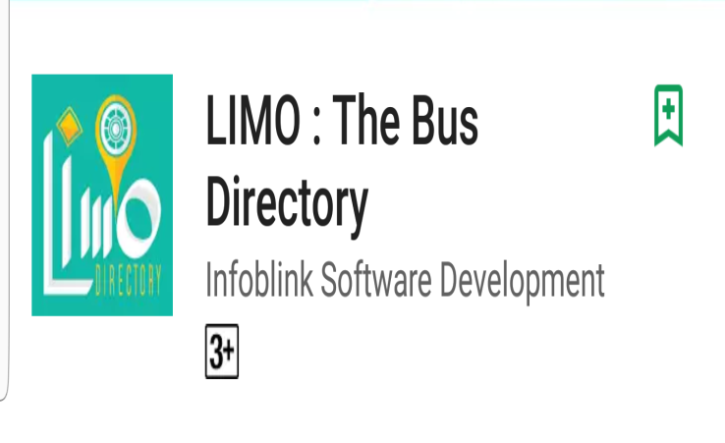**7-Bus routes directory**; for Citybus network in Kuwait city, and CTA & Mini Bus networks in Cairo. (More providers and cities are

coming soon).  
Passengers can search by the bus number to view its route, or can search by area name  to view all buses pas by that area, and their routes.  
  
Your contribution matters: You can help improving the data by adding the stop geographical coordinates or suggesting a correction or adding a missing information.  
  
The directory also offers live tracking for the vehicles, so any public or private service provider can opt in to offer the passengers ability to locate the bus and check its Estimated-Time-of-arrival.  
Educational institutions and universities can offer shuttle bus live tracking to the students and their parents, so the students can know the bus location and the arrival time.  
  
The service is ultra low-cost for any service provider, no investment needed on GPS devices (the drivers will us "Limo Directory Driver" APP), and it can be rolled out in few hours. No need to develop your own APP, as you can use the FREE LIMO Directory Passenger APPs as they are available for android and iOS devices.  
  
Limo Directory Apps for drivers and passengers can help any service provider (Taxi, Limo, Towing, Cargo or Bicycle rentals) to list all his vehicles and share their live location with all their clients.  
Individual freelance drivers can use the driver APP, with their loyal clients. So their clients can locate them anytime and check their availability (Free or Busy), and call them.  
  
Small and local Limo operators can list their vehicles and show their brand and phone contacts to get booking request directly to their office from the neighborhood. They can still work under their own brand with ZERO investment on making APPs.

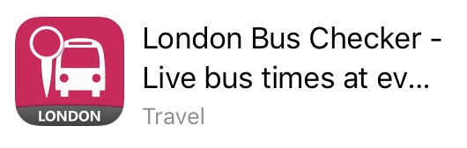

**8-london bus checker**

It is international

London Bus Checker ™ is the best-selling

app that brings Live Bus Countdowns to your mobile or smartwatch.

Standing at any of London's 20,000 bus stops, you'll get real-time arrival information for each bus, live from GPS receivers in each vehicle. You need literally never wait for a bus again!

That's not all - you get full route maps, live Santander ™ Cycle Hire dock info, disruptions, travel tips and much, much more - all for free! London Bus Checker will even wake you up when you get to your bus stop.

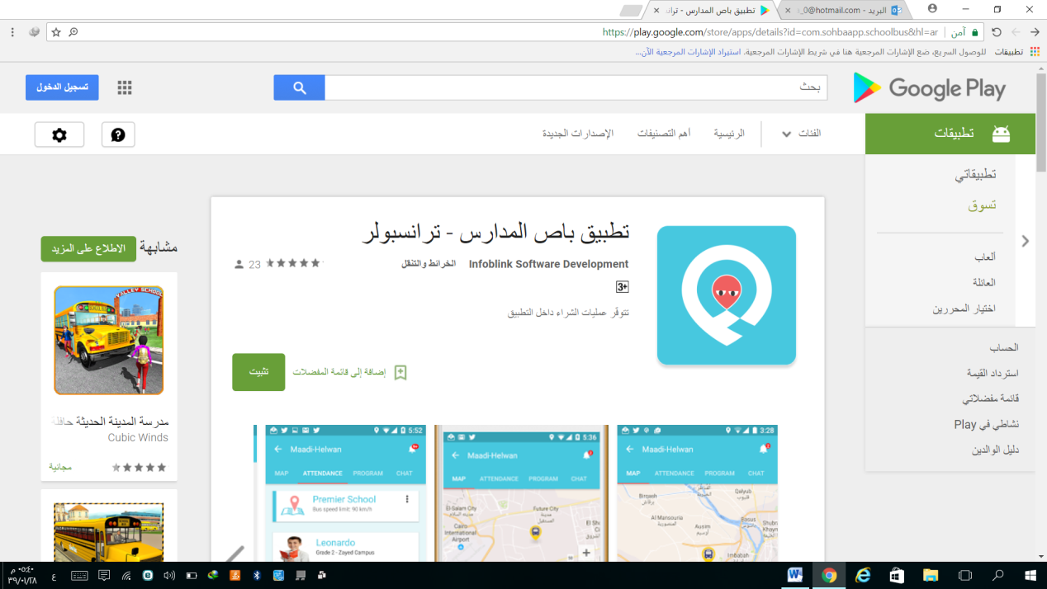***Arabic******applications***

**1-The application of the school bus**

**Infoblink Software Development**

A specialized system and an integrated approach in the management of school transport, with the application of Arabic for parents and supervisors and drivers, available to all schools and nurseries in all countries of the world

works through mobile supervising or driver without installing tracking devices in buses.

application mobile parents to follow up the bus, and communicate with the supervising authority or school.

can activate the system and application in a few minutes.

added the name and logo of the school and appears in the application of the parents.

**Features:**

1- complete monitoring routes, and bus speed and Momentary notifications in case of exceeding any driver of speed

2-system is completely without buying or Installing the GPS devices in buses

3-Mobile Application that allows people to follow the bus place momentarily and communicate with the supervising authority

4-Registration dates for horse and descending students, sending a Momentary notifications to parents to make sure

not to leave the child in the school, or not to forget the child inside the bus

5-The security and secrecy of data, with the identification of relatives of each child responsible for the follow-up to the bus or allowed to receive the Child

6-Integrated Management System and follow up with reports of the discipline of drivers

7-Application of the supervising authority and the driver pointers all data required for students of each bus and addresses on Google Maps , Thus ensuring smooth and service discipline, even in cases of switching the supervising authority or the driver between lines

* 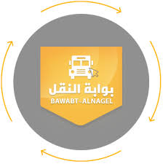**2-Bawabt alnagel**

Its application that connect people that look for transportation [college, school, personal use, trips, employees} with registered transport companies with the ability to reservation and look at companies information and rate it.





* **3-Hafilaty**

The aim of this application is to provide a means of communication between end users of TTC’s services and the public in order for TTC to increase the quality of the company’s services. Users can receive live real-time information, announcements, and report incidents related to the company’s services.

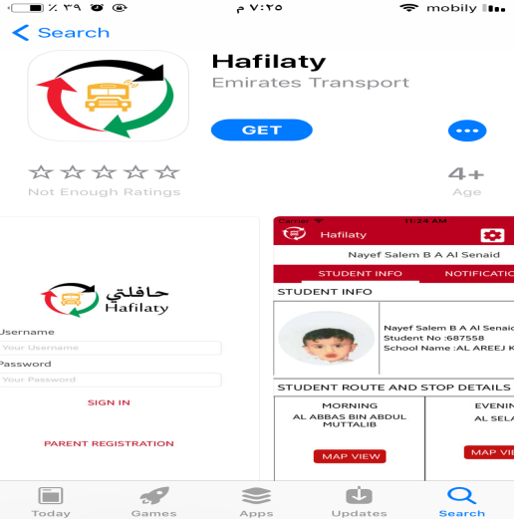 **4-Hafilaty 2**

Emirates transport maintaining student safety during the daily transport by school buses through the daily operations and safety procedures on roads. Emirates transport is providing new services through this application to notify students' parents in real time to insure them they arrived safely through application notifications Application Objectives: Increase the levels of student's safety and security during school transport trips. Confirm students' identification inside school buses during the daily trips. Provide School Trip and Buses Data Enhance School Transport operations within ET

Application features:

Identify the location of School Bus during the school Trip Display Trip, Driver, Bus and Attendances Details Display time for morning and evening trip View information for more than one student for the same parent Live information and alerts Display students pick up and drop off Location on the map Data security and privacy where Parents can view their student's data only



**5-our schoole bus**

Parents are often worried about their children and seek ways in which they can feel more reassured about their child’s security. Driven by this concern, the CEO of SNS startup Mustafa Almusawa saw this social need and found the right way to address it. The company’s goal is to make parents feel confident about the security of their children.

THE SCHOOL BUS APPLICATION

The idea behind the school bus application is centered around actual parents’ needs. With [this application](https://itechcraft.com/portfolio/school-bus-tracking-application/), the CEO wanted to find a real-time tracking solution for worried parents. As a result, the application is beneficial to both parents and school administration. The app allows parents to view the exact location of the school bus at all times. Moreover, it helps in the administration for the school. As they are able to manage the routes and drivers.

THE USE OF THE APPLICATION FOR PARENTS

Parents only need to download the application to their mobile devices to track the bus and get notifications. The application allows to follow real-time bus movements along the route and inform parents when the bus arrives at school. When the bus is approaching a bus stop which is nearest to a child’s home address, the parent receives a message about the bus coming. This way children

don’t need to waste any extra time waiting at the bus stop. This makes the process of sending children to school time-efficient. Furthermore, it also helps parents to feel more confident about their children getting to school safely.

THE USE OF THE APPLICATION FOR BUS DRIVERS

The driver application can be installed to driver’s mobile device equipped with GPS tracking and 3G connection.  This allows the bus driver to get the optimal route with bus stops projected next to students’ addresses. At the same time, the driver has access to traffic information and school location. The route is automatically modified if certain students are absent from school. Real-time detection of the students present on the bus is made possible by Bluetooth scanning of iBeacons that students carry in their school bags. If any of the children are left on the bus upon arrival at school, the driver can immediately contact their parents through the application.

THE USE OF THE APPLICATION FOR SCHOOL

Our School Bus application is also an added value for schools that choose to adopt the system. The school administrator can manage all the buses and routes through the control panel. The system allows to manage the database of drivers, parents, and students, create and modify bus routes with bus stops automatically generated next to students’ home addresses, provide drivers with the fastest way to pick up students and see at any time which students are on the bus with the help of iBeacon technology.

This application responds to users’ needs around the world, as it improves the communication between parents, drivers and school administration. To appeal to a wider audience, the company has developed native applications both for [iOS](https://itunes.apple.com/ru/app/our-school-bus/id1142149382?mt=8) and [Android](https://play.google.com/store/apps/details?id=com.smartnavigationsystems.ourschoolbus) platforms.



**6-springdales school dubai**

Description Springdales School is one of India's most distinguished private schools. Established in 1955 by veteran British educationist Mrs. Rajni Kumar, the school quickly grew from a small nursery to a full-fledged educational institution and made a distinct mark with its vibrancy and fresh approach. This application is a guidance for parents. It is very useful and provides real-time information. Features 1- Parents can track fleet/bus of their children live on the map using this application along with route, bus number, attendant number, name and stop details.

2- Parent can call directly to bus attendant using call feature in bus info section. 3- Parents can get pickup and drop off timings of their children in buses along with push notifications.

3- Parents can get entering and exiting time of their children in school campus along with push notifications.

 4- Parent can receive bus arrival notification prior to the arrival of the bus at their stops either for picking up in morning or dropping off in afternoon

5- Parents can set preferences for turning offlon multiple notifications.

6- Parents can use this application on multiple phones using same credentials so they can easily be able to monitor their children from their workplaces using their own smartphones.

7- Parent can see monthly attendance report of their children.

8- Parent can get late/absent children notification.

9- Parent can see events in the event calendar.

10- Parent will immediately receive SMS when children will not be picked up by the buses.

**6-wusul**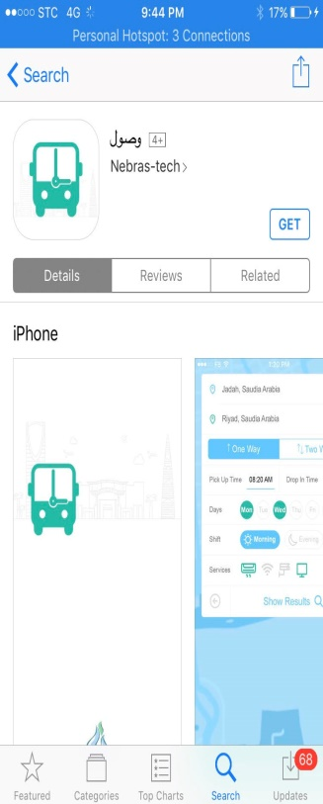

**Description**

- Application Access is the easiest and fastest way to access bus transport requests and employees within Saudi Arabia

- Choose the closest to you from among the many transport companies within the Kingdom with the possibility of evaluating the companies according to your satisfaction

- Just specify the location, the university and the dates of departure

- You will always receive a timely alert for the bus ride



**7- track ware:A unique system for the management of school tours linking school, parents and buses with one system by means of instantaneous and direct alerts**

The school management system helps the school administration monitor and track the movements of their bus fleet to ensure the safety of students as they move to and from school. This new technology provides features that allow people to connect with the school tour by sending notices before the bus arrives at home, when boarding and getting off the bus and providing a quick and instant communication mechanism with the residents.

Parents can send coordinates of their accommodation through the application, which helps the school to organize school tours with ease. It also helps the school management system to know the numbers and names of students on buses at any time during the school tours.

**for school**

The school management system helps you manage your bus fleet efficiently by turning it into smart buses. School management can identify bus routes more efficiently using the program. The program also helps reduce fuel consumption and increase the efficiency of the bus fleet.

Direct follow-up system on the map

Direct updates on the school's monitoring platform to see the number of active and completed rounds and the number of students on the buses

Geographic barriers are defined for drivers on the map

Keep records of bus movements for 30 days with reference and printing at any time

Provide information that helps in assessing the performance of drivers and escorts

Attendance and absence on the bus

Multiple notifications and alerts help you know the status of your school trip

Easy to use platform.

**Benefits of applying the location of the school bus:**

All schools and schools can rely on them to follow their children and students easily and from anywhere.

Track bus traffic directly - Our system will tell you about the bus site at any time during the school tour and you can follow the bus's movements directly through your computer screen or your cell phone.

Geographic barriers - The school management system allows you to set up barriers on the map for each bus to prevent any change to the school route, even if it happens inadvertently or accidentally.

Rapid Response - The school management system helps you deal with emergency situations by locating the bus on the map.

Communication - The possibility of parents telling the school if their son is absent from the bus through the application, which saves a lot of time and fuel consumption.

The school management system is designed with advanced positioning technology and is constantly updated and developed by adding additional benefits.

As the school management system tracks bus movements and student arrival and departure times, this makes the school administration and students feel safe about the safety of students and the convenience of using an easy tool at hand.

**For parents**

This app instantly tells parents about the location of their children as they move to and from school through notifications and alerts reaching their mobile devices. An alert arrives before the arrival of the bus at a predetermined distance to prepare for their son to board the bus without wasting time. Parents are alerted when their children get off the bus and when they arrive at school. Some information, such as the dates and times when children get up and get off the bus, can be retrieved with notifications.

One application for several children

One of the advantages of the school management application is that parents do not need to use multiple applications to follow the movements of each of their children who are attending the same school or in other schools with the same application. This application is enough for them to follow the movements of all their children

Immediate update of the bus site on track

Parents can follow bus movements during the round trip directly from the start of the morning tour to the moment the son returns home

• Follow the movements of the Jr. bus during the school tour.

• Alert by application when the son climbs or gets off the bus.

• Alert parents about the expected arrival of the bus home when the bus is close to the house at a predetermined distance.

**For drivers**

**-Security**

The school management system tells the driver about the order of the student to be brought along with some details such as a picture of the student and the phone numbers of his family. The driver can also use the application to find out the number of students independent of the bus and to ensure that it is in order to bring the students as the site receives the title of each student on the map Identification

**-Identification**

The application displays the student's residence address as well as the image on the driver's screen to be aware of the identity of the student who climbs or gets off the bus, which helps to prevent the error of identifying any student.

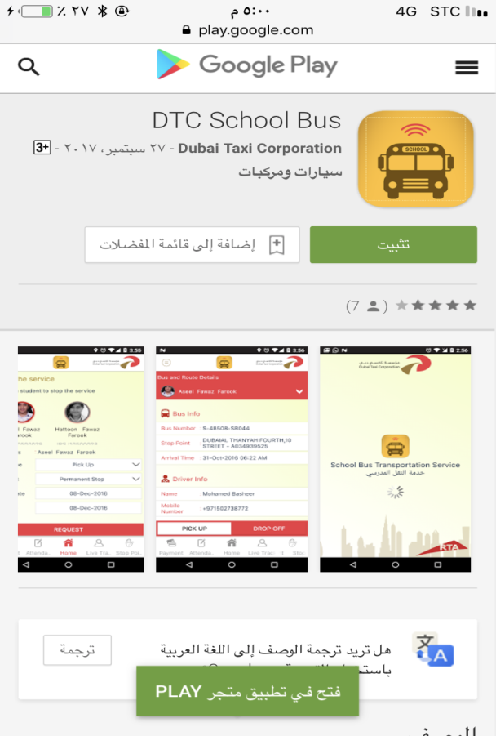

**(DTC) school bus**

**The Description:**

Dubai Taxi Corporation (DTC) offers school bus transportation for students studying in Dubai Emirate which is customized to meet schools, nurseries, and other student requirement. Our buses have been selected in accordance with the highest international quality safety standards for school transportation service and providing a portal for parents to register the students. This portal is available for mobile phones as well in order to ease the process of obtaining the school transportation service. This app is for parents to download & install on their mobile phones and make use of it as they travel around the world.

Parents will use this app in the following order.

1. Registering parents (new parent registration)

2. Adding students (enlisting student in School Transportation Service).

3. Selecting the stop points (from where to pick or where to drop the student).

4. Payment (making payment by credit/debit card).

5. Stop service request (requesting to stop the service).

Further, in this app parents are allowed to view and also edit the profile of themselves and children

Application at the level of the Emirate of Dubai in the United Arab Emirates (at the Arab level).

**Name: Salma Soliman Salah Alsenani ID: 3453524**

**Data input:**

1-school information (name- logo- location)

2-student information(name-age-class)

3-bus information (status-bus number- bus speed- location )

4-driver recognition

5- bus logs

6-bus arrival time

7- time count down

8-time tables

9-service schedule

10-stander cycles

11-search for bus stops*

12-select the stop point

13-input trip maps

14-add student to school bus

15-input witch time student in the bus

16-student attendance

17-line status

18-line cams

19- send notification

20-poyment

**Data output:**

1-school information (name- logo- location)

2-student information(name-age-class)

3-bus information (status-bus number- bus speed- location )

4-driver recognition

5- bus logs

6-bus arrival time

7- time count down

8-time tables

9-service schedule

10-stander cycles

11-search for bus stops*

12-see the stop point

13-view trip maps

14-see witch time student in the bus

15-student attendance

16-line status

17-line cams

18- receive notification